**Non-Profit Journalism—Issues Around Impact**

**A White Paper from ProPublica**

**By Richard J. Tofel[1]**

This paper was commissioned by LFA Group: Learning for Action on behalf of the Bill and Melinda Gates Foundation. It seeks to chart the issues around the quest to understand and better measure the impact of journalism, particularly non-profit journalism (or other journalistic work funded philanthropically). It focuses on the experience of ProPublica, a non-profit investigative journalism organization which has won two Pulitzer Prizes, including the first Pulitzer ever awarded to an online news organization (2010) and the first such prize ever awarded for material not published in print (2011). From its inception, and in accord with its stated mission, ProPublica has quite self-consciously measured its own success by the impact of its journalism, i.e. by the change and reform that journalism has spurred.

**The Quest for Measurement**

The quest for measurement in the social sector has accelerated in recent years. Non-profits face increasing pressure for quantifiable results from numerous stakeholders. Funders are attracted by the potential of journalism to spur change; some have imported or adapted business methods into their work, talking of “investments’’ and “returns.’’ Increasingly, executives at these non-profits come from business backgrounds and are comfortable seeing results in numbers rather than words. The news media note the non-profit sector’s increasing size and occasionally seek a greater semblance of accountability.  Legislators and regulators occasionally push for stronger oversight of tax-exempt entities. And all of this has been accentuated by the rise of digital technologies which have made it possible for new institutions to emerge so rapidly, as well as to measure instantly and precisely the sorts of social phenomena which were previously charted by anecdote or, at best, annual survey.

But despite a great deal of talk at conferences and convenings, and even a fair amount of written material, it must be acknowledged that it is still early days in efforts to measure the work of the social sector. Few non-profits yet define the sort of impact they seek to produce-- even fewer do so before they begin work. Terminology is loose, and often confusing, sometimes so much so that one is left to wonder if the effect is not intentional.

And on the funding side, to be candid, the situation is, if anything, more problematic. Funders tend to be even less precise than grantees about the impact they seek-- even about what they mean by "impact." Accountability for non-profits is on the rise, although it surely still lags behind that of the business sector; genuine accountability among institutional funders remains very rare.

In the nation’s newsrooms, an increasing number of which operate on a non-profit basis, discussions of how to measure success have long generated some discomfort and a fair amount of confusion. Advertising was and remains the most significant driver of newspaper and magazine profitability, and advertising pricing was importantly dependent on the quality of content, but editors and reporters have always been quite uneasy about seeing increased advertising (or, these days, slower decreases) as any indicator of their work. Circulation provided a more comfortable benchmark, especially as publishers had long ago identified a “virtuous circle” around which better content led to higher circulation (or higher prices for the same circulation) which led to greater demand for advertising (or higher rates for the same advertising) which created profits that could fuel more and better content. But this virtuous circle has broken in recent years, with print circulation falling almost everywhere, seemingly irrespective of product quality, and with digital circulation (and recently even circulation revenue) increases unable to keep profits up. Reporter productivity might have been another measure of newsroom success, but most attempts to measure it have been hamhanded and unsophisticated, evoking fears of rule by unknowing “bean counters.”

Impact, of course, might long have been a measure of newsroom success, but for reasons discussed below, it has never truly aligned with the goal of those who owned and managed publishing companies, and newsrooms’ own views about impact have been largely vague, and mostly rhetorical. At least in the world of non-profits, that is now changing.

**What Do We Mean By Impact?—A Taxonomy**

Before discussing how impact may be tracked and measured, it is necessary, of course, to define what we mean by “impact” in a journalistic context. A survey of even the meager literature in this field, and conversations with those who have thought about the question most thoroughly and carefully, leads to one immediate conclusion: A great deal of confusion has been engendered both by using the term “impact” incorrectly, and perhaps even more by assuming that one definition of “impact” will suffice across varying kinds of journalism.

Put most simply, different sorts of journalism have different objectives, and therefore will produce—seek to produce—quite different sorts of impact. What do we mean by this?

“Hard news”—the reporting of new facts, the bread and butter of wire services, all-news radio, the news (as opposed to opinion) portions of 24-hour cable television news, and the many Internet services that derive much or all of their content from these services—seeks to *inform*. The “impact” of such journalism would seem fairly straightforward to measure, at least in theory. Pre- and post- studies could measure the degree to which consumers of such services knew of particular events or facts before and after their exposure to the journalism involved. Or, perhaps more practically, consumers might be asked, post facto (and to the extent they recall), when and from what source they learned of particular facts. A sophisticated survey of this sort of impact should consider secondary and tertiary effects, especially in light of the rise of social media, which is very likely increasing the extent to which people are learning of hard news from other people they know, who may, in turn be learning of it from journalistic organizations.

But while the principal impact of hard news may be measured rather straightforwardly, we will not dwell on it in this paper, for a number of reasons. First, hard news is not the work of ProPublica, and the issue is thus beyond the paper’s scope. Second, and perhaps more controversially, there is considerable evidence that hard news, much of which is of direct economic value to at least some readers, is among the forms of journalism least endangered by the business crisis of the press. That is, hard news, at least at the national level, seems likely to remain a profit-making business, and the measurement of its impact will likely be undertaken by market-driven forces, including those undergirding advertising and business-to-business sales of information.

Another area of journalism which should be noted, but which is also outside the scope of this paper is journalism as entertainment. It is important to note that this is by no means confined to journalism *about* entertainment, though there is a great deal of that. Journalism *as* entertainment also includes much of what, in an earlier time, was described as “feature writing.” It has significant value, with the best of it being a high art. And the business crisis of the press, to be sure, has increased the pressure to produce more entertaining journalism, even to the exclusion of other types of content. But impact is not, by definition, the aim of such work.

It should be noted, of course, that the framing or phrasing of hard news and the selection of feature stories can themselves have important impact. But this effect is not the goal of such journalism, and not its primary consequence.

Next, and also outside our scope here, is journalism of opinion. This is the area in which new technologies—most notably the Internet, with means ranging from blogs to Twitter, and multi-channel cable television, with opinion channels from across the political spectrum often masquerading as “news”—have increased the supply of journalism most notably. Opinion journalism seeks to persuade. Without doubt, such journalism can have impact. And that impact, again as with that of hard news, would seem fairly readily measurable. Pre- and post- studies are again possible, but more helpful may be work correlating particular views with varying media consumption, as well as time series studies of the focus of particular opinion outlets and given subjects or stories. Also again, however, this is not generally the kind of journalism in which ProPublica engages, and we will leave questions about its impact to others.

What remains?

Two other types of journalism can have important impact, and with them we finally get to what this paper *is* about: explanatory journalism and investigative journalism.[2] These two types of journalism also have different goals. Explanatory journalism seeks primarily to elucidate, while investigative journalism, even if sometimes only implicitly, seeks change. The impact that results is thus also different: the impact of explanatory journalism will be determined by measuring how much readers’ awareness or understanding has increased, while the impact of investigative journalism must be judged by how much things beyond the reader have changed. ProPublica engages in both sorts of journalism, and both sorts of impact are explored below in more detail.

Explanatory journalism is sometimes a precursor or follow-on to investigative journalism, particularly when it engages in what Yochai Benkler calls an “adjudicatory” function, not only laying out contending positions or arguments about the facts of an issue, but establishing which of them are accurate—and which not. Such writing can complement investigative journalism, which is why ProPublica has, over its first five years, come to add a considerable amount of explanatory journalism to its journalistic mix.

Impact from explanatory journalism is centered on affecting the reader, and is therefore far easier to measure. Again, pre- and post- studies can gauge awareness or understanding, including the understanding of aspects of a problem or an issue’s complexities. Alternatively, and more simply (although perhaps less reliably), as with hard news, readers may be tested on their understanding, and asked from whence their knowledge is derived. Such measurement, of course, should also allow for the fact that some of the effects of explanatory journalism may be secondary and tertiary, that is, one reader to whom something is explained may then explain it another—with the possibilities for such interaction (and to some extent its tracking) dramatically enhanced by social media.

Beyond this, a key factor in charting the effectiveness of explanatory journalism will be the engagement of readers. Engagement—the intensity of reaction to a story, the degree to which it is shared, the extent to which it provokes action or interaction—is always positive, but with explanatory journalism it is especially critical. Greater engagement will tend to indicate both how likely an explanatory story is to resonate with readers, i.e. how much it has explained to them, how likely they are to share it, either through social media or just word of mouth, how likely they are to be moved by it to act. Moreover, while engagement will occur (or not) and can also be measured with respect to other types of journalism, it is most likely to result in impact beyond the reader in the case of explanatory reporting.

When engagement is the objective, measuring its impact, beyond the usual web traffic indicators, involves tracking the volume of republication (ProPublica uses a code beacon to automate this process, at least where republication is authorized), follow-on stories, and sharing via Facebook, Twitter and otherwise. Measures of the interactivity provoked, including through the volume of web comments and the size and activity level of Facebook groups and other similar fora, will also be important.[3]

**Impact and Explanatory and Investigative Journalism**

From these basic points, some important observations about impact from explanatory journalism may be derived:

* More is better—the larger the audience reached (either directly or indirectly), the more people whose awareness or understanding may be enhanced
* But reach and impact are not the same. Having a larger audience does not *necessarily* mean that more people have learned something. If the substance of the journalist’s explanation is not accessible by the larger audience, for instance, no greater impact is achieved. This crucial distinction between impact and reach will be addressed at greater length below.
* Engagement is also not the same thing as impact, but the two may be closely correlated for explanatory journalism.

Investigative journalism is different. The best definition of what constitutes “investigative” journalism, at least in this author’s experience, is journalism that seeks to reveal something that someone with some modicum of power (a person, group or institution) seeks to keep a secret. In this respect, investigative journalism is unlike most reporting, which announces, transmits or explicates something which someone (whether powerful or powerless) is seeking straightforwardly and transparently to have disseminated—from public meetings and political campaigns to financial and commodities markets, to news conferences, press releases and promotional events of all kinds, to cultural, entertainment or sporting events.[4]

Understanding and charting the impact of this sort of work is far more difficult. Impact from investigative journalism always involves changes beyond those in the minds of readers, to changes in what journalists often term the “real world,” actual changes in behaviors, policies, practices, legislation or some such. Because of this, it is important to note, at the outset, that whether impact actually results from any particular story or set of stories is not entirely within the control of the journalists who create the story; happenstance can, and frequently does play a significant role.

In some cases, the way to effect change will be to raise awareness or change the minds of many readers (again directly and indirectly) and then rely on those readers, through concerted political or other action to bring about change. In such cases, measures of engagement may again be important. But this will actually be the exception rather than the rule. In many more cases, the potential for impact from investigative reporting will lie in the hands of a few key decision-makers, or with larger issue elites.

As a consequence, more audience and greater reach does *not* necessarily enhance investigative journalism’s potential for impact. Large audiences, even if reached, may not be moved to act, or even to press others to do so. Targeting particular specialized audiences may prove more effective—and has, on a number of occasions, for ProPublica.

For instance, in 2010 ProPublica and NPR News jointly undertook an investigation of traumatic brain injuries (TBI) to American troops in the post-9/11 war zones and the Pentagon’s failure to adequately recognize the frequency and severity of these injuries. The reporting was strong, detailed, powerful and—despite initial denials by Defense officials—entirely accurate. It was widely disseminated; NPR programs on which it was featured alone have many millions of daily listeners. But only when the stories began to be first reprinted in and then published in partnership with Stars and Stripes, the independent newspaper published by the military, distributed on bases in the U.S. and around the world and closely read by senior officers, was the Pentagon moved to change policies, alter practices, and appropriately recognize and support the injured. Stars and Stripes has an average daily readership of about 300,000; only a fraction of them, of course, read the TBI stories.

Similarly, in 2011, ProPublica, initially in partnership with the Center for Public Integrity, revealed that the federal Department of Education (DOE) was maintaining a system for handling disability exemptions from student loan repayments entirely separate from the disability system long in place at the Social Security Administration. The result was long delays in handling requests, substantial hardship for disabled former students, and considerable unnecessary government expense. Only when our stories on this subject were published in partnership with a niche publication confined largely to elites, the Chronicle of Higher Education, did the DOE eventually disband their separate disability system. The print circulation of the Chronicle is less than 65,000 (although its audience is substantially larger online)—and again, only some of these readers read the ProPublica stories. But those who did included the readers empowered to change things.

**Making Sense of Reach**

Beyond specifying what types of journalism seek impact, and in what ways, another definitional issue is critical here: making clear what impact itself is, and is not.

As noted above, reach is not impact. That is, it is simply not the case that larger audiences for a particular piece of journalism necessarily correlates with greater resulting change. If millions of people read an article, but none of those in a position to do anything about the situation described are among them (even after secondary and tertiary distribution), or if those who could act fail to do so, nothing will happen—this is true by definition. And conversely, if only a few people learn of a story, but those few can and do act on it, then the impact can be great. It may often be the case that the chances for impact are enhanced by securing larger audiences, but even this is not always true—it depends on the composition of the audience and the mechanisms through which change might be effected.

To be sure, there are circumstances in which reach may be a proxy for impact. If the mechanism through which impact is going to be achieved is the ballot box, for instance, then more reach (at least among eligible voters) is better. If “reach” is a proxy for an idea’s acceptance, as it generally is with regard to citation of scientific papers, for instance, and acceptance will yield change from the status quo ante, then, again, quantifying reach can be meaningful as an indicator of impact.[5]

But even in cases where reach is desirable, common sense is in order in applying it. As Ethan Zuckerman has written, “The danger of traffic-based analytics driving journalism is that you may end up with newspapers that look more like Demand Media-style content farms and less like the civic guardians we want and need them to be.”[6]

On a related note, one of the oldest (and silliest) games in public relations and advertising has been to take the cumulative total audience of various publications in which an article or advertisement has appeared and to claim that the resulting enormous number has in some sense been the number of “impressions” recorded. Thus, at one recent convening, one foundation grantee said its material had been republished to an audience of more than 350 million (substantially larger than the U.S. population), while another claimed nearly 130 million readers “through syndication and reprints.” This sort of thing is unhelpful, and always has been. In measuring reach, what counts is not the total number of people who may encounter a particular publication in which a story appears, but the number who read the story itself. That this number may be difficult to obtain is no excuse for using the larger (readily available) “circulation” figure.

**Distinguishing Mere Outputs**

In the philanthropic context, it is especially important, both for funders and recipients of funding, also to understand what sort of impact is being sought. The principal focus of this paper—as with the mission of ProPublica—is on impact on civil society, i.e. on change that spurs or embodies reform. As generally understood in philanthropy, this type of impact will be the consequence of an “outcome” of journalistic work. In the same way that reach does not equate to impact, journalistic “outputs” (stories produced, audiences reached, page views recorded, perhaps even journalists able to be employed) do not equate to outcomes in this sense.[7]

This is crucial to bear in mind, because it relates closely to a major problem in American philanthropy today. Donors frequently say that they seek outcomes (or impact), and nearly always say that they place greater importance than previously on evaluation, measurement, “return on investment.” But outcomes are much harder both to trace and measure than are outputs—and grantees are often expert in being able to count outputs (which occur in their fields of expertise, e.g. journalism) but less well grounded in gauging outcomes or impact itself (which often occur in other disciplines, e.g. criminal justice or health care or environmental science). The result has been a widespread confusion of means and ends—a tendency to conclude that a straight line can be implicitly drawn from outputs to outcomes, and that progress on the former necessarily heralds progress on the latter.

Timelines must also be borne in mind. As we will see, impact frequently will not result for months, or even years, after an initial story is published. This need not present a problem unless those involved fail to bear it in mind. But bear it in mind they must—in part for the practical reason that there will be cases in which the timeline for impact exceeds that of a given grant period (no less a journalistic prize year). Sophisticated funders will want to make sure they are evaluating impact when they must—but then perhaps occasionally re-evaluating it as time passes.

One side note is in order: There is one segment of philanthropy that will want to measure impact differently: philanthropy aimed at the condition of journalism itself, rather than the subjects journalism covers. For donors with a focus on journalism, outputs, in the sense defined just above, may be equivalent to outcomes. If a donor’s objective is to demonstrate or support new models for journalism *as such*, measures of impact will vary considerably—and much of what is laid out in this paper may not apply. Reach or engagement, for instance, in the view of such funders, may then constitute impact—as may journalism awards or the ability to attract other funding.

Before moving on to the mechanics of charting impact, there is another key issue with which we need to wrestle: Is it even appropriate for journalists to seek impact from their work? Does such an objective cross the line from journalism into advocacy?

Here the non-profit form of journalistic enterprise may actually offer an advantage.

**Legacy News Organizations and Their Mission**

The mainstays of American journalism, immediately before the advent of the digital era, were almost all organized as parts of profit-seeking companies, most of them publicly held. Such companies have, as their organizing principle and mission, to maximize returns for shareholders over the long run.

To be sure, some of these companies, including those that owned most of the nation’s best newspapers, were controlled by families that had earlier held them as private entities, responsible only for producing enough profit to keep the family owners as well-fixed as they wished, and otherwise able to plow revenues back into improved product quality. Even when they had, in the 1960s and early 1970s, converted to public ownership, these companies could be run in a similar manner, sometimes yielding sub-standard margins, but doing so with an eye to better journalism—and placing at least a rhetorical emphasis, when shareholders pressed, on the maximization of *long-run* returns.

But, like so much else, the digital revolution has changed this. The companies remain public, and where their family owners have not sold out (as they did at The Wall Street Journal, Los Angeles Times, Philadelphia Inquirer and Miami Herald, for instance), profit margins are no longer able to be set as if at will. Yet, profits remain the imperative. Shareholders insist on them, corporate managers continue to be compensated for producing them. What has been laid bare is what was only implicit before: that profits come first, and journalism second, that journalism can be served only to the extent that profits are already assured, that in any actual choice between the first dollar of profit and the next increment of journalistic quality the need for profit will prevail.

This is not exactly the view from America’s best legacy newsrooms. Many in these newsrooms see their own goals as at some variance with those of the corporate officials who set their news budgets. They continue to view journalism as a calling, and look to impact as an important objective of their work. One indication that this is so can be found in the sort of work journalists choose to honor as the best in their field. A look at Pulitzer Prizes for journalism awarded in the last three years reveals that seven citations out of 30 noted the impact of the work being honored. For the George Polk Awards, summaries of 23 of 37 awards over the same period note the work’s impact.[8]

The quest for impact is clearly an important motivator of newsroom staff, and an important differentiator of work in journalism from that in other fields that may offer more money, or (in recent years) more job security. This quest has played a significant role in why reporters and editors who might have had more lucrative opportunities elsewhere remained in journalism. As the recent Tow Center report on “Post-Industrial Journalism” put it, “a desire for ‘impact’ does undergird journalistic belief structures.”

And then there is the nexus between the quest for impact and the preferred position of the American press under the First Amendment to the United States Constitution. As journalists never tire of reminding themselves and others, theirs is the only business to receive special constitutional protection. The Framers placed the press in this position because of its role in enhancing and safeguarding democratic governance—that is, because of the potential for producing impact. The protected legal position that has resulted, especially since the decisions of the Supreme Court in New York Times Co. v. Sullivan (1964) in libel and the Pentagon Papers cases (1971) in prior restraint as well as the less expansive protections for sources and rights of access, are bulwarks not only of the role of the press, but also key factors in reducing the business risks of journalism that seeks impact.

Despite this, however, and increasingly, the dire straits of the journalism business are forcing greater alignment between newsroom and corporate objectives. As news budgets are cut almost everywhere, content that costs more in dollars than it yields *in dollars* is being squeezed down, and out. Editors today are forced to be far more aware of the business consequences of their own choices than they were 10 years ago. This is not the result of some sort of moral failing on the part of these editors—or even on the part of their corporate bosses—it is simply a reflection of the facts of business in an industry in decline.

And, unfortunately, there does not seem to be any demonstrated correlation between journalism’s impact and its economic value. In fact, much of the most successful journalism, in terms of impact, presents the classic economic problem of positive externalities. Great communal benefit may result, but little or none of its value may be recoverable by the party—in this case journalists and their employers-- causing that value to be created.

**Some Advantages of Non-Profit Journalism**

Non-profit journalism has an advantage here. The impact of its work is often the stated test of its value. ProPublica’s mission—the reason it exists-- for instance, is “To expose abuses of power and betrayals of the public trust by government, business, and other institutions, using the moral force of investigative journalism to spur reform through the sustained spotlighting of wrongdoing.” The stated mission of Voice of San Diego is “To consistently deliver ground-breaking investigative journalism for the San Diego region. To increase civic participation by giving residents the knowledge and in-depth analysis necessary to become advocates for good government and social progress.” The Center for Public Integrity uses similar terms: “To enhance democracy by revealing abuses of power, corruption and betrayal of trust by powerful public and private institutions, using the tools of investigative journalism.”

These are not just words—missions matter. To the extent that a non-profit such as these has the resources, its job is to devote those resources to producing impact. There is no other, higher goal.

Moreover, the objective of impact has practical consequences: Where for-profit news media must work actively, for instance, to choke off unauthorized (i.e. unpaid) reprints of stories, non-profits can actively promote free reprints through Creative Commons licenses, or offer re-publication rights at very low cost to regular partners, significantly extending a story’s reach and enhancing its potential for impact. ProPublica, which has employed a Creative Commons license since its inception, saw page views under these licenses grow dramatically in 2012, to a level sometimes more than half that of the million-plus monthly page views on its own web site.[9]

Non-profits can share not only reprint rights to stories, but the essence of stories themselves. Where a for-profit news organization has every incentive to want to “own” a story—to have readers, sources and others identify a story solely with them, thus enhancing circulation revenues and perhaps even the reputation on which much of advertising revenue can depend—non-profits, being mission-based, can and do see amplification or even appropriation of one of their stories as contributing to reach, and thus perhaps impact.

One area in which this has been evident to date is in the localization of stories based on national databases. ProPublica’s “Dollars for Docs” is a paramount example. “Dollars for Docs” is a project, launched in 2010, tracking pharmaceutical company payments to promote the use of prescription drugs. ProPublica compiled a national database of such payments—accounting for more than a billion dollars in such payments. ProPublica has published national stories exploring the issues raised by these payments, as well as efforts to regulate or limit them. The database is also accessible to consumers through ProPublica’s web site, and has received more than four million page views since it was launched.

But beyond that, ProPublica has actively worked to encourage local news organizations around the country to tap into the database and develop stories about payments to doctors in their locales. Its reporters and editors have convened conference calls, explaining how the database works, what it contains, and how such stories can be reported. “Reporting recipes” have been published. Formal alliances have been formed with the NBC owned-and-operated television stations and Digital First’s newspapers to facilitate the publication of such stories (on “Dollars for Docs” and other ProPublica news applications) on a timely basis. To date, more than 125 different local news organizations have published stories drawing heavily on “Dollars for Docs;” many have taken advantage of an online widget created by ProPublica that permits users to remain on a local news organization’s web site while searching the ProPublica database. All of this, of course, enhances impact. None of it would be in the interest of a for-profit publisher seeking to monopolize credit for a story and centralize web traffic to it.

**Should Journalists Even Seek Impact?: Journalism vs. Advocacy**

But is the objective of impact consistent with sound principles of journalism? If impact is the aim, what distinguishes journalism from advocacy?

This is a complicated question, and it admits of many answers, but, in short, there are profound differences between journalism and advocacy. The most profound of these may begin with process, but culminate in much more: Journalism begins with questions and progresses, as facts are determined, to answers. Advocacy begins with answers, with the facts already assumed to be established. In short, advocates know before they begin work the sort of impact they are seeking, while journalists only learn in the course of their work what the problem is, and only after this can they begin to understand the kind of impact their work might have. Advocates seek impact based on their *opinion* of societal needs; journalists may identify possible steps toward reform, but should do so only from *facts* they have established. Even in more ambiguous situations, this divergence in approach goes a long way to explain what may seem to outsiders a quirkiness in journalism’s self-restraint in some areas but not others. Thus, Clay Shirky has pointed out that the New York Times regularly advises readers on which plays to attend, but essentially never on which political demonstrations to join. Beyond the basic differentiator that theater reviews are opinion journalism, there is also the critical distinction that theater reviews are grounded in the journalist having already experienced the play—having determined for the reader many of its “facts.”

With these differences between advocacy and journalism in mind, how should journalists approach the issue of seeking impact from their work?

ProPublica’s answer to this question has, from the first, been to embrace impact as a goal, but to seek it using only journalistic means.

Thus, when a problem is identified by reporting, and when a solution is revealed as well—e.g., nurses with criminal records are not having their nursing licenses revoked but could be, or presidential pardons are being issued and withheld on a racially discriminatory basis due to Justice Department internal guidelines that could be changed at the stroke of a pen—it is appropriate for journalists to call attention to the problem *and the remedy* until the remedy is put in place.

In such cases, the press should feel perfectly comfortable reminding readers (including public officials and others in a position to effect change) that a problem exists and that a solution is available. Squeamishness about staying with such a story until reform is undertaken has been a weakness of the traditional press in recent decades, not a sign of virtuous neutrality.

In some circles, such journalism is derided as “crusading,” and said to conjure memories of the presumably less sophisticated practices of an earlier time. A few responses to this argument are in order. First, it is worth noting that nearly all available information indicates that newspapers (which is what people are almost always talking about when they refer to such “crusades”) were both more widely read and substantially more trusted by readers when these practices were more common than they are today. Those facts may not be coincidental. Second, the fact the leading crusading publishers and editors (think Pulitzer, or Hearst) engaged in occasional abuses, sometimes out of partisan or personal motivations, at other times for economic gain, does not alter the fact that many of their “crusades” yielded important civic reforms.

Moreover, the heart of the objection to journalistic “crusades” rests on the implicit notion that all readers of a particular publication read every story that the publication publishes—so that no story, or even most parts of stories, need ever be repeated, recast, reframed or refreshed. This was never true, and is even more at variance with contemporary practices, where many readers come to stories in atomistic fashion, through social media or search, while nearly all readers feel increasingly pressed for time. In such a news ecosystem, rigorous follow-ups, repeated attention to complex subjects, and varying approaches to telling a story to varied audiences, may be the only way to actually bring a subject to widespread attention. The unlimited “news hole” of digital publishing, where one story need not crowd out others, makes such an approach far easier for digital native publishers.

That said, there is a line that journalists should not cross—and it *is* the line between journalism and advocacy, properly understood. Journalists, for instance, shouldn’t lobby. (Non-profit journalists are largely legally forbidden from doing so, but even if they were not—or to the extent they are not-- this would be a violation of the common understanding of journalistic ethics.) Many reforms might, arguably, be aided by the election of one candidate or another to office, but even ideologically-driven journalists should not engage in partisan (i.e. political party) activity of any sort. Too much of their credibility would be lost if they did, especially given the close and often bitter partisan split in our society. The organizing of public demonstrations can aid a reform cause, but it is not the place of journalists to organize (or to participate in) such demonstrations.

One special issue for non-profit journalism is that of political endorsement editorials. For for-profit news media, these are at the heart of constitutionally protected speech; for non-profits, they are essentially forbidden by statute and regulation. Whether such a legal distinction is good public policy (or even constitutional) is beyond the scope of this paper. In ProPublica’s case, we have always found these rules untroubling, as we publish almost no opinion journalism. What does seem important, and is closely related to the question of distinguishing journalism from advocacy, is the need for those organizations that do regularly publish both news and opinion, to clearly delineate one from another—and preferably to maintain a “Chinese wall” of individual editorial responsibility between the two.

All of this said, it is imperative that journalists not be dissuaded in their work by critics and story subjects who deride as “advocacy” journalism that which is not. Fact-checking the statements of public officials and especially political candidates is not advocacy, for instance, even if one party or one side in an election is more often cited as making misstatements. Explaining complicated realities is not advocacy even if, as with some aspects of a number of important national debates, one side seeks to deny that reality. As Senator Moynihan famously remarked, “Everyone is entitled to his own opinion, but not to his own facts.”

As noted above, even proposing solutions to the problems identified by investigative reporting may be appropriate in some circumstances. The work of David Bornstein and Tina Rosenberg on what they call “solutions journalism” is quite thought-provoking in this regard.[10] Many of the issues that work raises are beyond the scope of this paper, but it is not beyond it to claim the common ground that, at a minimum, where the solution to a problem is obvious or would be undisputed—once the problem is acknowledged, of course—it is wholly proper for the journalists revealing the problem to note this.

An example can be found in ProPublica’s coverage of shortcomings in the 21st century presidential pardons process. Pardons are one of the only pure prerogatives of the presidency, an essentially royal power. So it is clear that any systemic problem with them could and should be addressed by executive order. When ProPublica established that race discrimination was resulting from the pardons process, then, it was entirely proper to call for an order ending that discrimination. When the process was shown to be being undermined by an effort to protect the parochial interests of the Department of Justice at the expense of justice itself by disqualifying from consideration for pardons those who claimed to have been wrongly convicted, it is not “advocacy” to say that such a policy has no place in our country. Some values really are universal (or should be): race discrimination by the government is wrong (and constitutionally forbidden), protection of a government agency at the expense of the system it is charged with upholding is wrong. No reasonable person actually disagrees—which is why no one responded to ProPublica’s pardons stories by defending the process or the results they revealed. When something is literally indefensible, and when the means of remedy are clear and certain, journalists should not hesitate to suggest how change could occur.

**Thoughts on Story Selection**

This approach also yields an important point about story selection in investigative reporting. As we have noted, it should *not* be possible to fully anticipate a story's impact before the reporting has been done-- this is one implication of the reporting going where the facts lead. But there *should* be an argument that impact is possible. If there is not-- if the subject of the proposed story is some sort of irremediable injustice or problem beyond solution-- at least at a news organization like ProPublica whose mission is to seek impact, another subject should be chosen instead. (This is not to say that a solution must be easy, or the prospects for it immediate. Much of the best investigative journalism has concerned circumstances where it was clear reform would be hard, and would likely take some time.)

But once reporting has been completed and before a story is published, it *should* be possible to foresee possible impacts. Identifying these possible impacts can be critical in framing a story for publication, and in designing a communications and social media plan to accompany it-- in short, maximizing the chances for impact.

**How ProPublica Charts Impact**

Having laid out the issues surrounding the impact of non-profit journalism, it remains to chart how such questions play out in the life of one such organization, ProPublica.

ProPublica was founded in the latter part of 2007 and began operations in mid-2008. From the outset, its task was to publish investigative journalism that has impact. That was the objective that attracted its initial funders, it was (and remains) ProPublica’s stated mission quoted above.

ProPublica takes great pains to track the impact of its work. One of its guiding principles in doing so is that transparency in claiming (or disclaiming) impact is essential, precisely so that those outside ProPublica can concur in its own judgments about where impact has taken place—or can challenge those judgments.

ProPublica makes use of multiple internal and external reports in charting possible impact. The most significant of these is an internal document called the Tracking Report, which is updated daily (through 2012 by the general manager) and circulated (to top management and the Board chairman) monthly.

Each “deep dive” series undertaken by ProPublica is included in the Tracking Report.[11] The report records each story published, many of which are undertaken in partnership with other news organizations, and any prominent reprints or pieces following the work by others (with most of this data derived from Google Alerts and clipping services). Beyond this, the Tracking Report also includes each instance of official actions influenced by the story (such as statements by public officials or agencies or the announcement of some sort of non-public policy review), opportunities for change (such as legislative hearings, an administrative study or the appointment of a commission) and, ultimately, change that has resulted. These last entries are the crux of the effort. They are recorded only when ProPublica management believes, usually from the public record, that reasonable people would be satisfied that a clear causal link exists between ProPublica’s reporting and the opportunity for change or impact itself.

It may be useful to pause here for an important distinction inherent in the ProPublica Tracker: “opportunities for change” such as legislative hearings or the appointment of a commission are *not*, in themselves, “impact” in the sense we have been using that term, as they may sometimes prefigure change but do not embody it. Rather, to again employ a terminology introduced above, such opportunities are “outcomes” short of impact.

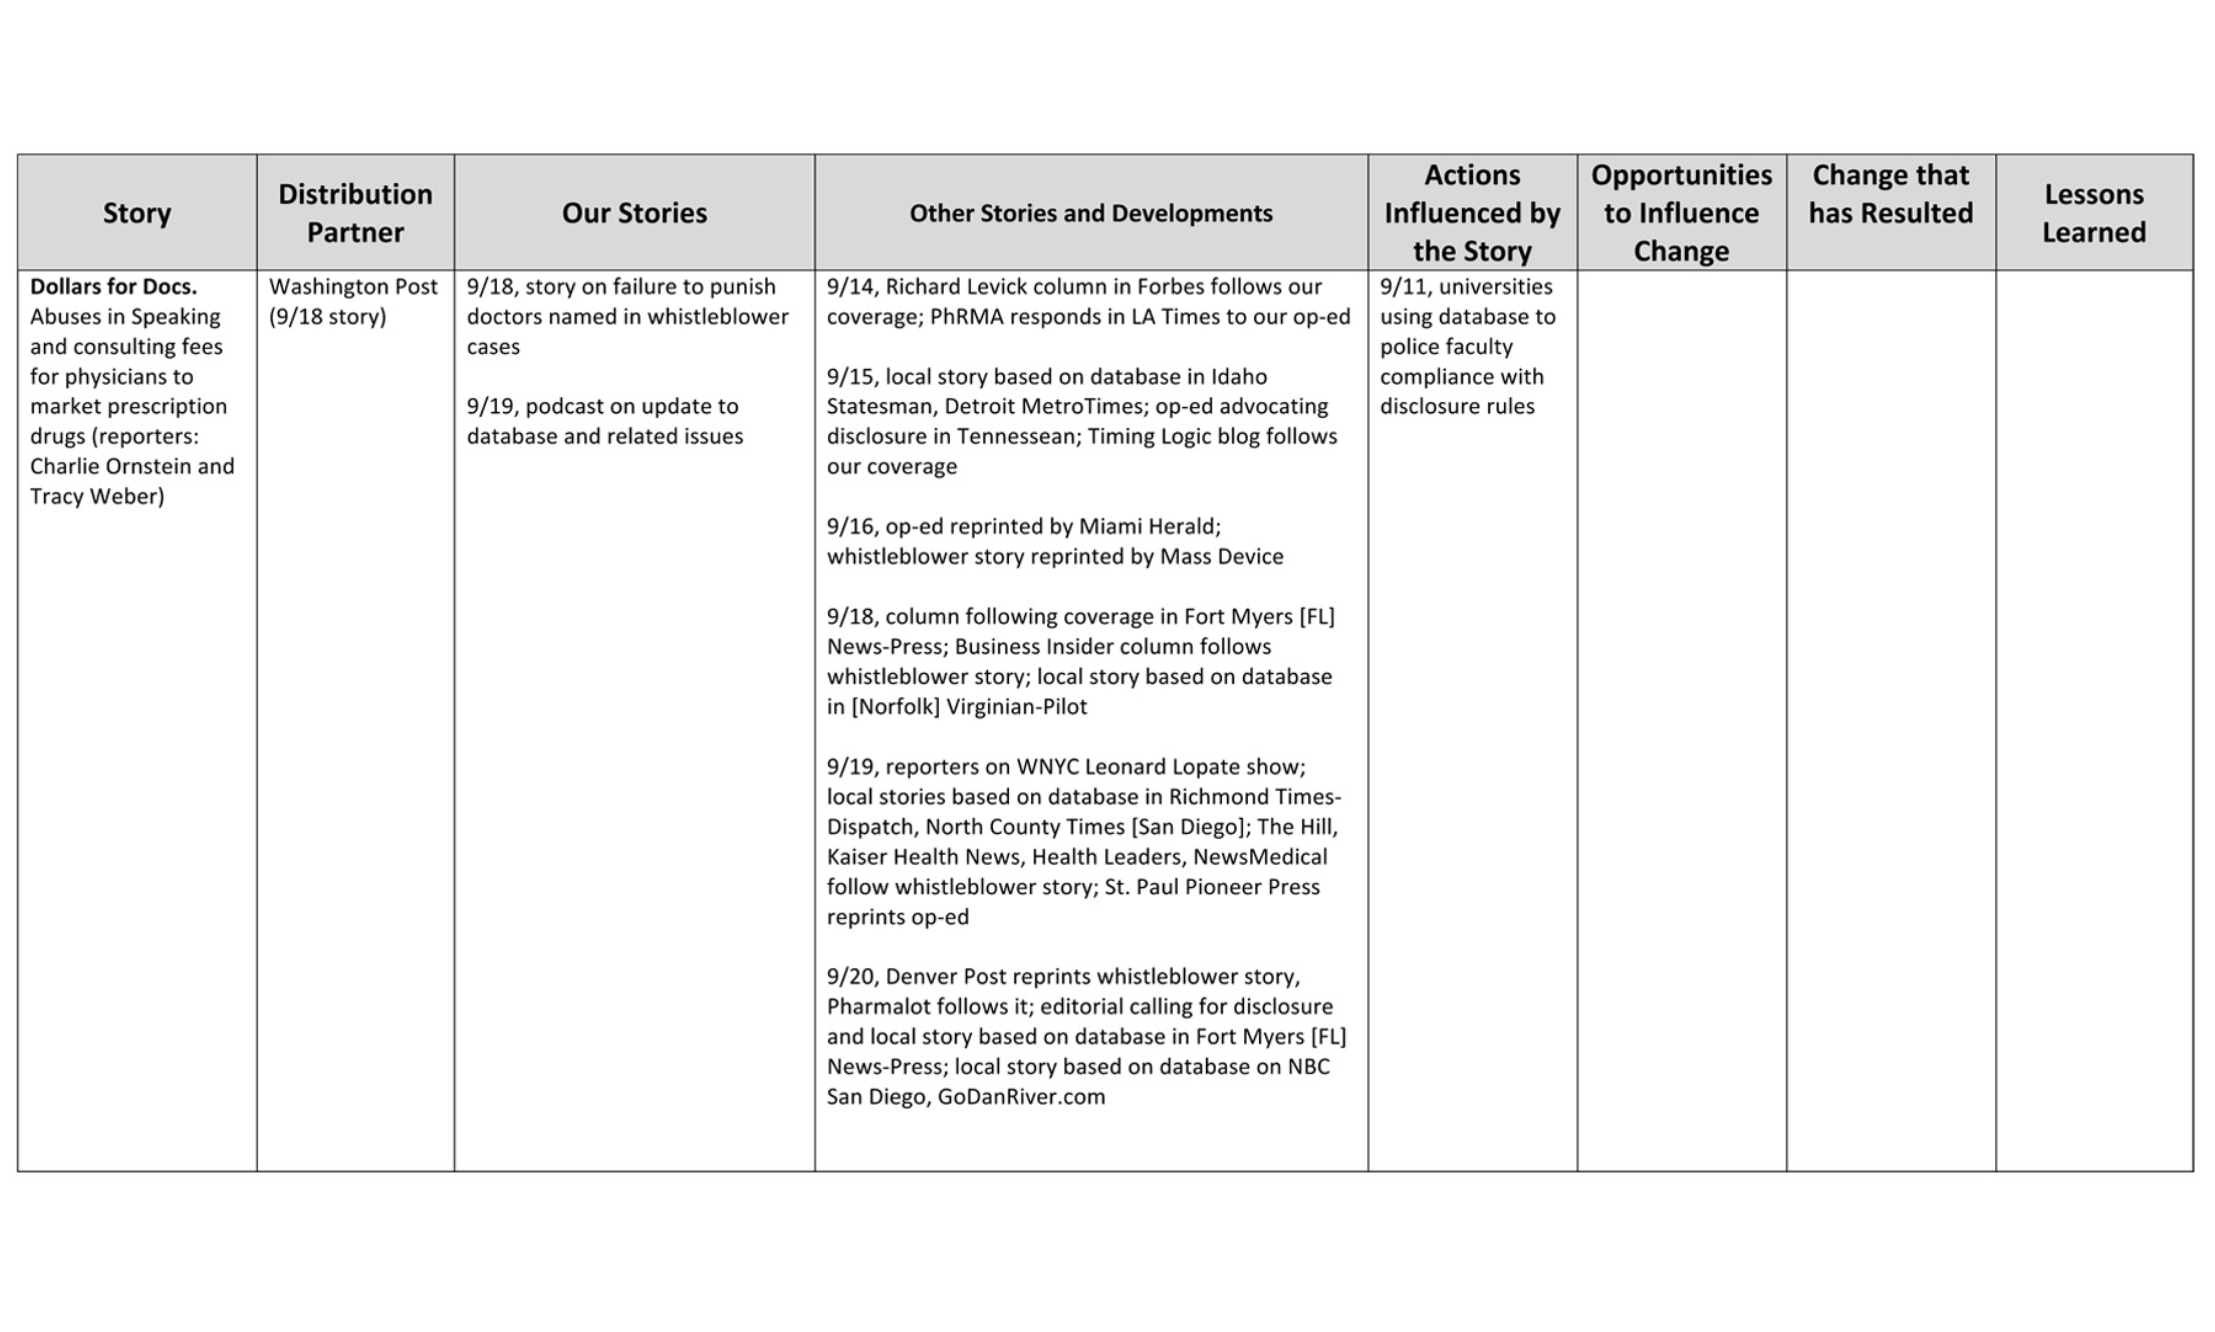

*ProPublica Tracker*

Returning to the Tracker itself, series can be tracked for weeks—or for years. ProPublica, for instance, continues to regularly track its reporting on hydraulic fracturing (“fracking”) for natural gas, which it essentially pioneered in mid-2008, and on which it has now published nearly 175 stories. Of course, in such a case, where our reporting has prompted an Academy Award-nominated documentary and extensive investigations by other news organizations, both national and local, and where substantial advocacy efforts have emerged around the country, causation becomes much more difficult to assess as time goes on. But having in some important sense helped light the fuse for all of this, ProPublica continues to monitor the debate carefully.

On the other hand, series do not remain on the Tracking Report forever. Once ProPublica stops reporting on them, formal tracking ceases. Sometimes impact continues—as it has, for instance, in some of the investigations triggered by the reporting on Wall Street practices that won ProPublica its second Pulitzer Prize in 2011. Possible prosecutions and fines continue to result from this work long after the reporters involved have moved on to other work, and ProPublica notes these as they emerge.

Each ProPublica Board reporting package contains an Impact Report. This pulls together, in much more compact form, an overview and summary of the conclusions that can be drawn from the Tracking Report since the Board’s last meeting. Impact for each series, both since its inception and since the previous meeting, is indicated; story partners are listed and a tally of recent stories provided. Where no impact for a particular series has resulted since the last meeting this is indicated clearly. Because judging when impact from work has occurred is subjective and sometimes complex, this report is prepared personally by the executive running ProPublica’s business operations.

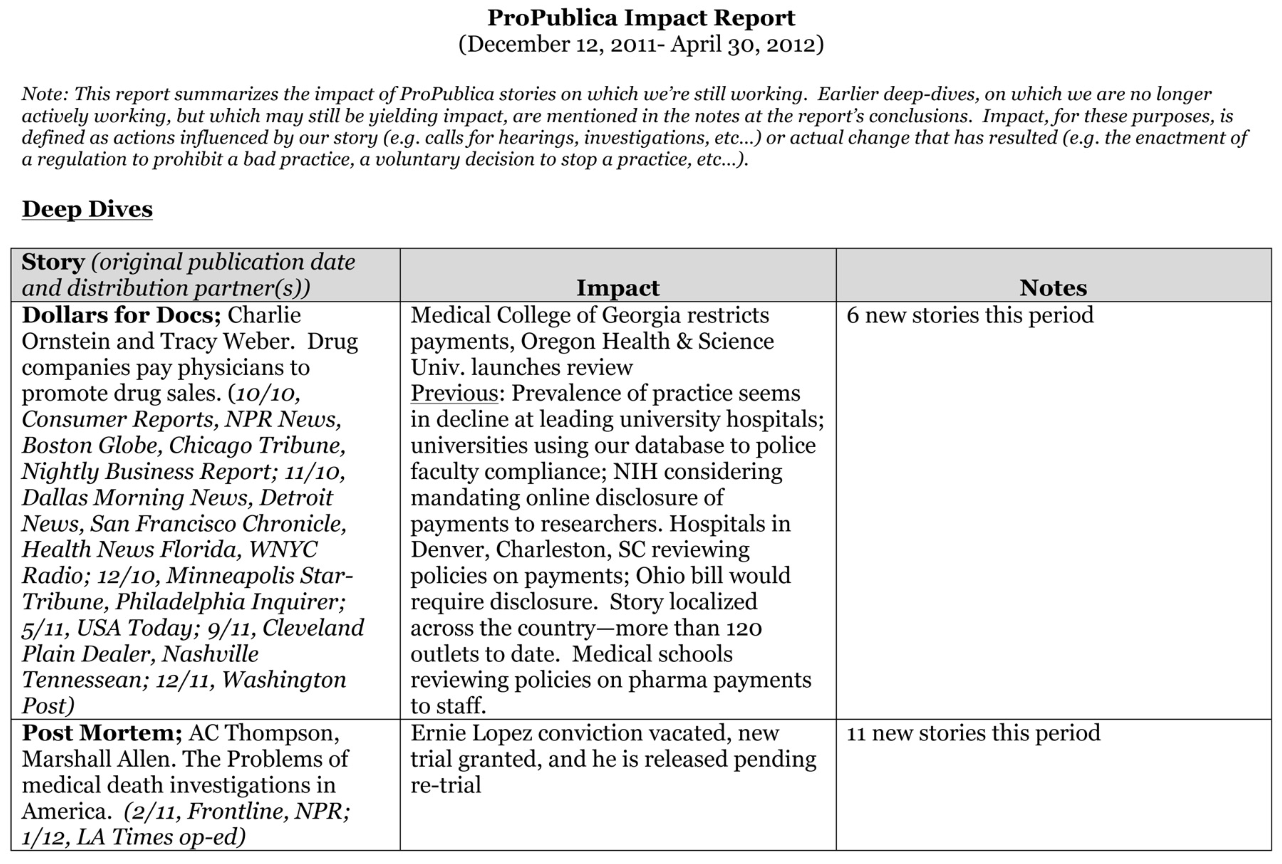

*ProPublica Impact Report*

The Impact Report, as a periodic summary, can also range somewhat more broadly than the Tracking Report. Impact from “one-off” stories is thus included. Such results in 2012, for instance, included that from stories on inappropriate financing of an upstate New York congressman’s trip to Taiwan, which resulted in his apology, refunding of the expense involved, new ethics training for his staff, an Office of Congressional Ethics formal investigation—and an unexpectedly close race for reelection, in which the ProPublica stories played a central role in television advertising and debate points by his opponent.

Results from explanatory reporting, including from standalone news applications, are also included in the Impact Report. These can, for instance, comprise measures of engagement by readers, as well as pick-up by other news organizations, such as the localized stories drawing on ProPublica’s Dollars for Docs, Nursing Home Inspect, Educational Opportunity Gap, Dialysis Facilities Tracker, and Stimulus Tracker databases.

The Tracking Report and Impact Report are both internal documents, but the final and most important test of ProPublica’s claims of impact comes when public credit is taken. This occurs occasionally on ProPublica’s web site (where a subsection of “About Us” is headed “Impact”), but most regularly with ProPublica’s annual report (the first of which was issued in January 2011 for activities in 2010) and its periodic interim reports to stakeholders, which have followed in the months of May and September of each year, covering work in the preceding four-month periods.

Each annual report and interim stakeholders report includes a prominent section on impact, enumerating instances in which ProPublica believes its work has prompted results. For 2010, this included eight items, for 2011 nine, for 2012 10. To date, none of these claims has been challenged. The possibility that they might be, of course, is an important check on any temptation to claim impact where such a claim might be insupportable.

The internal Tracking Reports and Impact Reports, and the external annual and periodic stakeholder reports chart outcomes and impacts (in the sense we have used those terms above). In building to these, it should be noted that ProPublica also carefully measures outputs.

|  |  |  |
| --- | --- | --- |
| ProPublica Impact | | |
|  | **Story** | **Impact** |
| 2010 | New Orleans police | Federal monitoring of department; officers indicted |
| dialysis | Government releases facility data after prodding |
| BP spill | Claims process streamlined |
| Chinese drywall | Habitat for Humanity remedial action, Lowes pays more |
| fracking | Limits placed on drilling in New York |
| federal caregivers database | Database overhauled, warning on limitations posted, oversight team replaced |
| psychotropic drugs in nursing homes | New law enacted in Illinois |
| MRI drug | FDA restricts use |
| 2011 | Collateralized debt obligations | SEC settlements for $400 million+; SEC proposes ban on similar deals |
| traumatic brain injury to troops | New guidelines for award of Purple Hearts |
| “Dollars for Docs” | Tightened rules, enforcement at university med. centers |
| fracking | NAS study, then EPA links to risks to water; more disclosure of chemicals by cos. And mandate by some states |
| Airport scanners | TSA orders independent review |
| Heart Check America | Lawsuite by Illinois AG, fine in Colorado |
| Allied Home Mortgage | Federal suit for fraud; HUD suspends company |
| New Orleans police | Federal consent decree; officers convicted |
| Mortgages | SIGTARP report bases HAMP critique on reporting |
| 2012 | Wild horses | Tightened regulation, restricted sales |
| Rep. Bill Owens | Money for Taiwan trip refunded, ethics training for staff |
| Presidential pardons | Justice Department review ordered; IG report finds failure to observe standards; clinic formed to aid applicants |
| FCC E-Rate | Training program for phone companies begun |
| “Dollars for Docs” | More universities restrict practice |
| Airport scanners | NAS study ordered; scanners removed from busiest airports |
| Opioids | American Pain Foundation disbands |
| Collateralized debt obligations | SEC settlement for $127 million, Massachusetts for $5 million in another case |
| Clarence Page | Returns funds for attendance at MEK rally, reprimanded |
| psychotropic drugs in nursing homes | Chicago doctor sued for fraud by Department of Justice |

Source: ProPublica annual reports

Separate reports from the communications staff of two full-time employees (first daily, next compiled weekly and then aggregated for each Board meeting) track each media interview and conference appearance by ProPublica reporters and editors, organized by story subject—thus paralleling (and supplementing) the Tracking Report, while casting a wider (comprehensive) net with respect to media outreach. The daily and weekly reports also gather all known pickup of ProPublica stories by other news organizations and leading bloggers.

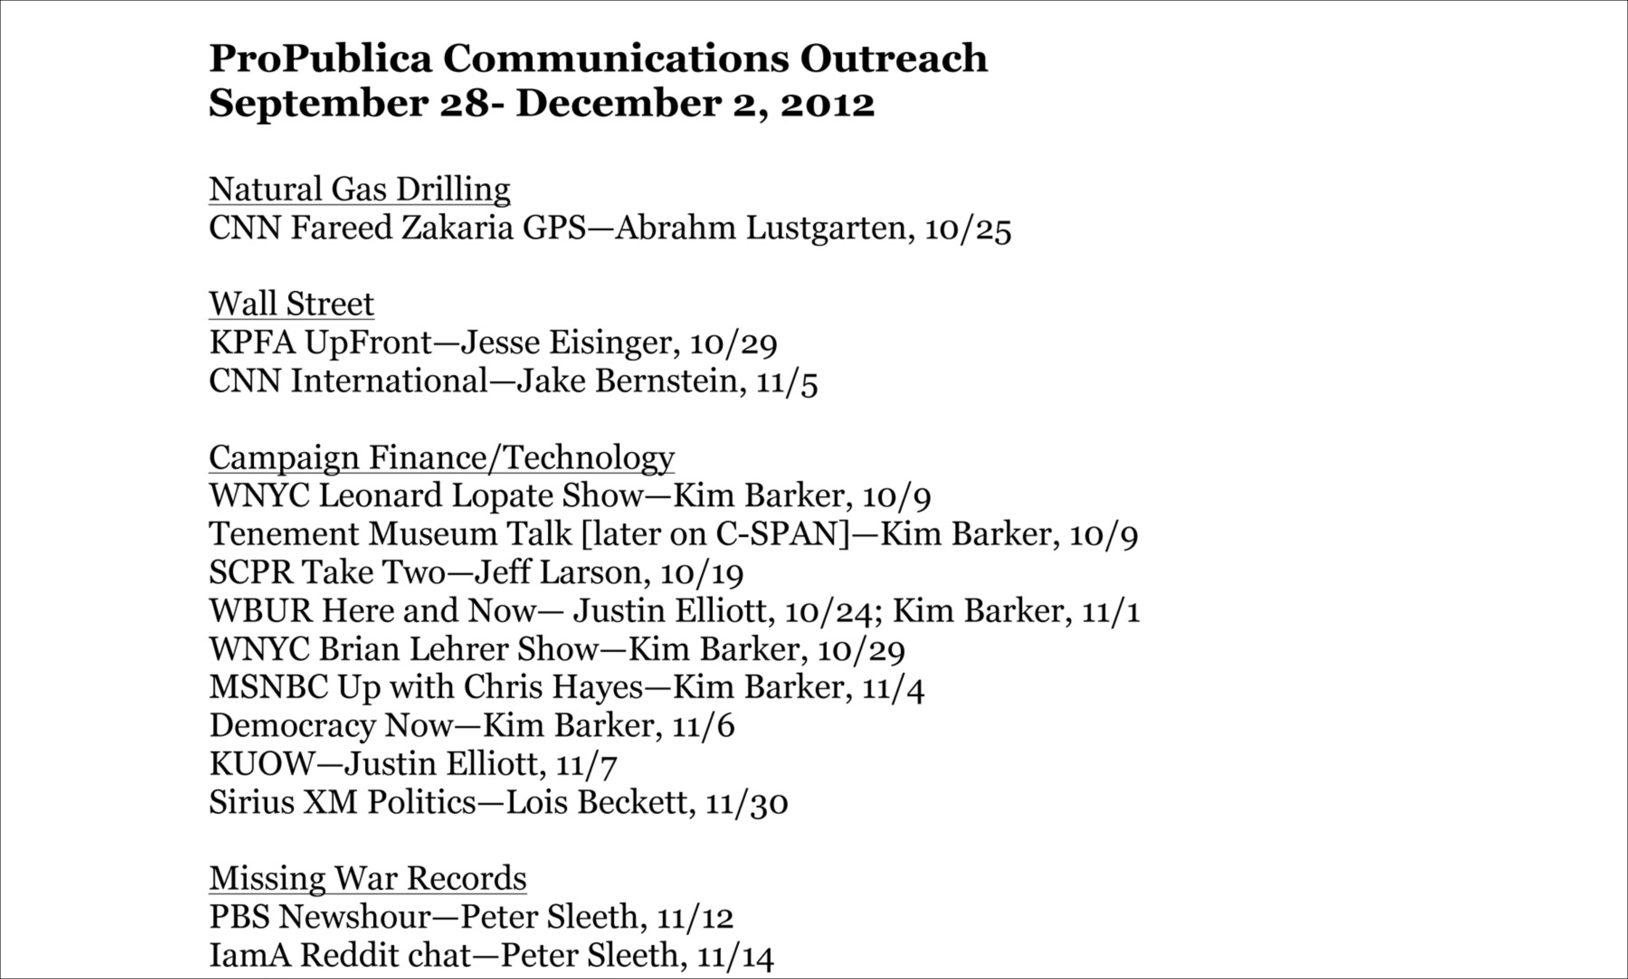

*ProPublica Board Communications Report*

Another group of reports comes from the news applications group, again on a daily and then weekly basis, tracing web traffic and the sources thereof, both in the aggregate and by leading story, but also including social media (Twitter, Facebook, email newsletter) follower counts, iPad, iPhone and Android app downloads and web reprints by others under Creative Commons. This material is gather from a number of sources, including Google Analytics and ProPublica’s “pixel ping” beacon for tracking web reprints. Given the “long tail” aspect of much of ProPublica’s work, the weekly reports include not only story traffic from the current period but also cumulative traffic to date to leading stories and news applications. The news applications group—a cluster of seven full-time coder/designer/journalists—has automated the creation of these reports.

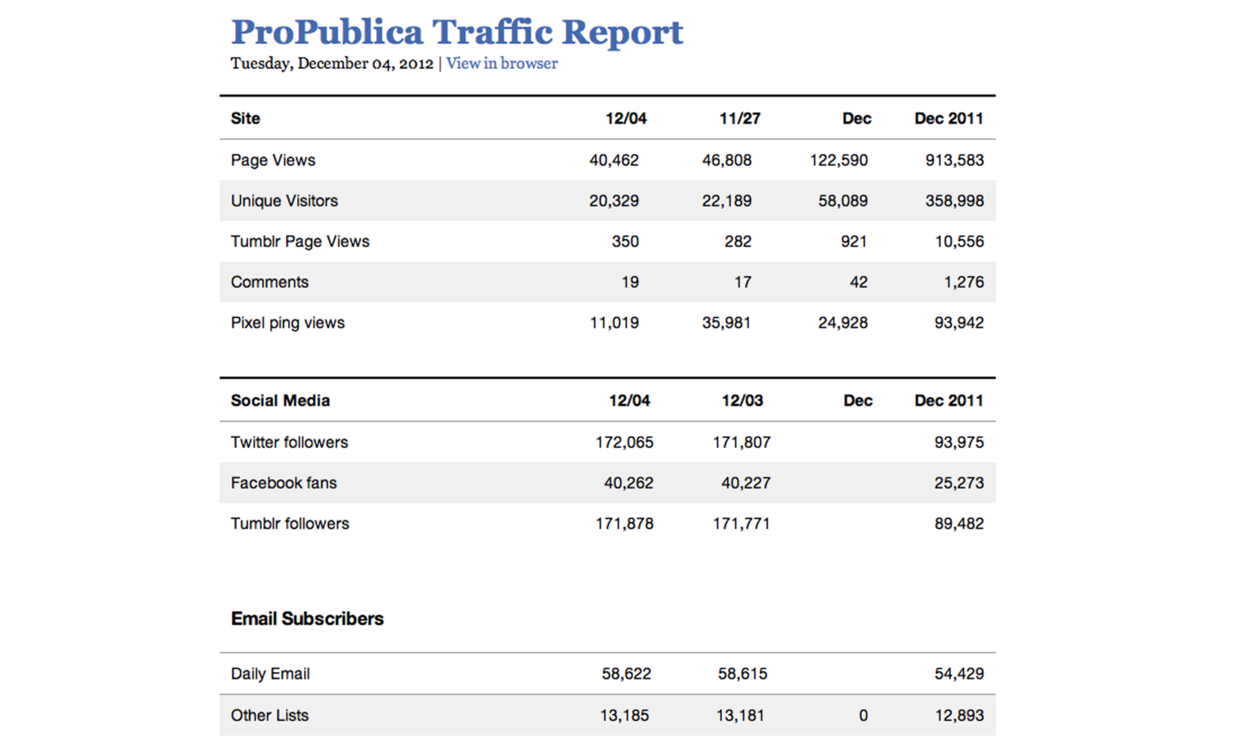

*ProPublica Daily Traffic Report (partial data)*

**A Few Tentative Lessons**

After nearly more than three years of tracking its work in this manner, what lessons might be drawn from ProPublica’s experience?

First, **true impact—in the real world change sense that we have been discussing it in this paper-- is relatively rare**. ProPublica has employed about 20 reporters in recent years. From their work, as noted above, its annual reports have been able to cite eight, nine or 10 instances of significant impact in each of 2010, 2011 and 2012.

There are varying ways to look at these results. One way would be to observe that most reporters, even at an investigative news organization generally regarded as high-performing, were not producing any noteworthy impact in most years. Another would be to note that the fraction of published items yielding important impact was quite small.

But there are other ways to look at these same numbers. One is to recall that greatness in a central aspect of what we still call our “national pastime,” hitting in baseball, has been historically determined to occur when success is achieved three times in ten—and that everyone involved now reflexively accepts this. The point is that without understanding the degree of difficulty inherent in any craft, it is impossible to intuit an objective standard of excellence. And the available evidence strongly indicates that a “high” “batting average” in investigative journalism will actually be a fairly low number.

Closer to home, another way to look at the numbers is to compare them to the results from other sorts of philanthropically funded work. As nearly everyone involved in institutional philanthropy would readily confirm, one significant bit of impact for roughly each million dollars spent in reform-oriented work is actually a high standard to which few donors would wish to be held.

Beyond this, some of the impacts from the work in which ProPublica engages—but, importantly, not all— are readily subject to cost-benefit analysis. The financial reporting that won ProPublica its second Pulitzer, for instance, has already resulted in the levying of more than a half billion dollars in fines and settlements paid to the federal government by financial institutions. As Eric Newton of the Knight Foundation has pointed out[12], such results alone could justify the existence of organizations like ProPublica for literally decades. But a caution is in order immediately after acknowledging this argument: Not all impact is quantifiable in this way—what is the economic value, for instance, of placing the New Orleans Police Department under federal supervision and curbing its history of official violence? And we should want to take great care that we not create pressure to undertake only that work the outcomes from which are likely to be quantifiable.

The next lesson from ProPublica’s experience, indeed, goes in almost the opposite direction: the importance of acknowledging that **impact is easier to identify than to conclusively “prove**,” and that those seeking to chart it must not shy away from an attitude that “I know it when I see it.”

Many of the various examples of impact cited in this paper might have difficulty withstanding a rigorous challenge in, for instance, a court of law or a philosophy seminar. Has their causation been proven beyond a reasonable doubt, or even by a preponderance of the evidence? Not if hearsay testimony is inadmissible. Not if experts cannot testify to ultimate questions. Not if common understandings must be the subject of rigorous logical proof or social science surveys seeking to establish that which we already accept. Especially not if we deconstruct the slippery notion of causation itself.

But these should not be—must not be—our standards. Just as journalism honorably stands as what Philip Graham memorably termed the “first rough draft of history,” so its impact must be measured carefully, objectively, but also roughly. While we should insist that impact itself be tracked with rigor and described with the greatest precision possible, we must not fool ourselves into thinking that it is subject to mathematical proof or even, in some cases, statistical reliability.

Moreover, while holding organizations like ProPublica to their missions, to their commitment to change, we need also **recognize** what Emily Bell has aptly termed **the “alchemy of impact,”** the very unscientific way in which impact often occurs. This alchemy includes a substantial measure of happenstance.

One of ProPublica’s most successful stories may offer an illustration. Written in 2009 and published in partnership with the Los Angeles Times, it detailed terrible shortcomings in California’s oversight of nurses. Criminal nurses were being left unchecked, often for years, after they had been identified. California’s system for professional discipline was badly broken, and the Board of Registered Nursing, the state agency responsible, was caught somewhere between denial and gridlock. The day after the story was published, then-Governor Schwarzenegger dismissed most of the members of the Nursing Board, and, soon thereafter, its top staffer as well. A reform process began immediately; it was as successful a story from the perspective of impact as one could imagine—and it was honored as a finalist for the Pulitzer Medal for Public Service.

But, of course, it might not have happened that way. The Governor might not have seen the story— although ProPublica’s partnership, in this case with the largest newspaper in his state, made this unlikely. Or the Governor might have been a person of different temperament—one less likely to act on the spur of the moment, or one deterred from acting by the political problem that he had appointed many of the Board members he then summarily dismissed. Or other pressing matters might have made action on the nursing issue impracticable because of a lack of time on the Governor’s part, or because of a perceived need to keep public attention elsewhere. None of these factors, had any of them prevented the action that did occur, would have lessened the purely *journalistic* value of the story; none of them would have changed how other readers reading it at the same time as the Governor experienced it. But any of the factors might have negated its impact.

In the long run, across a range of great and important stories, such factors will tend to average out—sometimes accelerating or aiding impact, sometimes retarding or preventing it. But with any given story, this sort of happenstance may well play a leading role. Those seeking to evaluate the impact of any given story (as opposed to a broader body of work) will need to bear this in mind.

A related issue will be the flow of news generally, and the difficulty of focusing public (or even elite) attention on particular questions at particular times. For this author, this lesson was first learned as a young press relations staffer in the Carter White House, where the Press Secretary’s office was adorned by with a needlepoint pillow bearing the ungracious reminder, “Don’t F___ Up on a Slow News Day.” That is to say, the impact of journalism will always depend, in important measure, on the other journalism with which it is competing for attention.

With all of this, perhaps the most important lesson is that **there is no one reliable measure of journalism’s impact**, no single algorithm that can be devised, no magic formula to load into a spreadsheet or deploy in an app. As Ethan Zuckerman points out, there are plenty of “simple and bad” metrics. What is needed is a set of complex and sensitive measures, constantly being adapted to new circumstances. Some—perhaps most, and the most important-- of these measures will be expressed in words. As Jonathan Stray has written, “Not every effect needs to be expressed in numbers, and a variety of fields are coming to the conclusion that narrative descriptions are equally valuable. That is still data, but it’s qualitative (stories) instead of quantitative (numbers).”[13] This is just the sort of suite of measures and collection of narrative accounts ProPublica has endeavored to capture with its Tracker, Impact Report, and traffic and communications reports-- and to ultimately distill and publish in its annual and periodic stakeholders reports.

Those reports, in turn, reveal the next important lesson with regard to impact: that it is **often a long time in coming,** and **any effort to measure impact should necessarily stretch over the longest possible period**.

Examples abound, both in ProPublica’s experience and beyond that. At ProPublica, it was two to three years from the initial reporting on fracking, for instance, before impact was widespread. It took 15 months from ProPublica’s first reporting on police violence in New Orleans to the Justice Department’s finding of systemic civil rights violations—13 months after those cases were described in detail in a partnership with the New Orleans Times-Picayune and Frontline. In November 2012, federal officials in Chicago brought Medicare fraud charges against a physician largely based on information in a ProPublica story published in partnership with the Chicago Tribune three years earlier. It has already been 14 months since ProPublica’s first stories demonstrating racial discrimination and other issues in the presidential pardons process, and while an official review is underway, no reforms have yet actually taken place. So while the 24-hour impact of the California nurses story is not unique, it is also not the norm.

Nor is this true only of ProPublica’s experience—it is often true elsewhere, and frequently the case with the most important investigative journalism of our time. It was four years from the Guardian’s first reports on phone hacking in the UK until the story took on a life of its own with the Milly Dowler revelations. Even in Watergate, it is important to recall that it was eight or nine months from Woodward and Bernstein’s first important reporting to the point at which Watergate morphed from a scandal into a crisis, and then a further 16 months or so until the day President Nixon resigned—the day President Ford referred to “our long national nightmare.”

Moreover, this is as it should be: We should not want, for instance, a criminal justice system that reaches judgments (and resolves against the presumption of innocence that is a cornerstone of our liberties) in hasty reaction to a published account.

These sorts of timelines are critical to bear in mind in assessing investigative journalism’s impact. If we seek to measure it within a calendar quarter of a story’s publication, for instance, we will frequently miss the most important results. If we insist on quarterly results—as has often been observed with respect to the management of American public companies—we will distort behavior, and reward thinking that focuses on smaller but more visible objectives over longer-term, larger targets.

At the same time, we need to recognize the practical problems this reality presents: those with oversight responsibility for investigative journalism (such as board members at non-profits, or top editors or publishers at large for-profit newspapers) cannot always wait two years to reach judgments about performance; prize judges must award prizes which implicitly and sometimes explicitly seek to reward impact on a fixed calendar that begins as little as weeks and hardly ever more than 15 months after publication; grant-makers must resolve questions about whether to renew grants based on a relatively inflexible calendar not devised with effective evaluation in mind. To a significant extent, this tension cannot be eased—it makes little practical sense to award prizes for work conducted the year before last—but awareness of the problem may limit it somewhat, and may, for instance, promote sensible changes, such as instituting different (and longer) terms for evaluation of management performance and grant effectiveness.

**Conclusion**

The problem of impact from journalism is a complex one—as the length of this paper perhaps attests. We hope the analysis here will contribute to thinking through and about this problem, and that some explication of ProPublica’s experience will prove valuable to our colleagues in journalism and our partners in philanthropy. There is much more to be said in applying the tentative conclusions presented here to other circumstances—and in contending about them in the first place. We welcome that dialogue, and look forward to learning from others’ reactions to this work.

**Partial List of Sources**

Interviews

Emily Bell, Director, Tow Center for Digital Journalism, Columbia Journalism School

Yochai Benkler, Co-Director, Berkman Center for Internet and Society, Harvard Law School

Aron Pilhofer, Editor of Interactive News, The New York Times

Clay Shirky, New York University

Jonathan Stray, project lead, Overview

Ethan Zuckerman, Director, MIT Center for Civic Media

Written Materials

Anderson, C.W. at al./ Tow Center, “Post-Industrial Journalism: Adapting to the Present,” 2012

<http://towcenter.org/wp-content/uploads/2012/11/TOWCenter-Post_Industrial_Journalism.pdf>

Brock, Andrea, et al./ Center for Effective Philanthropy, “Room for Improvement: Foundations’ Support of Nonprofit Performance Assessment,” 2012

<http://www.effectivephilanthropy.org/assets/pdfs/Room%20for%20Improvement.pdf>

FSG Social Impact Advisors/ John S. and James L. Knight Foundation, “Measuring the Online Impact of Your Information Project: A Primer for Practitioners and Funders,” 2010

<http://www.fsg.org/tabid/191/ArticleId/428/Default.aspx?srpush=true>

Gates Foundation, “A Guide to Actionable Measurement,” 2010

<http://www.gatesfoundation.org/learning/Documents/guide-to-actionable-measurement.pdf>

Green, Daniel, “Eyeballs and Impact: Are we measuring the right things if we care about social progress?,” Skoll World Forum, 2012

<http://skollworldforum.org/debate/what-role-does-the-media-play-in-accelerating-social-progress/>

LFA Group: Learning for Action/ Bill & Melinda Gates Foundation/ John S. and James L. Knight Foundation, “Measuring the Impact of Engagement through Media: A Summary of Three Convenings,” 2012

LFA Group: Learning for Action/ Bill & Melinda Gates Foundation/ John S. and James L. Knight Foundation, “Deepening Engagement for Lasting Impact: Measuring Media Performance and Results,” forthcoming

LFA Group: Learning for Action/ National Center for Media Engagement, “Measuring Public Media’s Impact: Current Practices, Promising Opportunities,” 2012

Priem, Jason et al., “The Altmetrics Collection,” Public Library of Science, 2012

<http://www.ploscollections.org/article/info%3Adoi%2F10.1371%2Fjournal.pone.0048753>

Richardson, Breeze/ Reynolds Journalism Institute, “Measuring Community Engagement: A Case Study from Chicago Public Media,” December 1, 2011

<http://www.rjionline.org/blog/measuring-community-engagement-case-study-chicago-public-media>

Stray, Jonathan, “Metrics, metrics everywhere: How do we measure the impact of journalism?,” Nieman Journalism Lab, August 17, 2012

<http://www.niemanlab.org/2012/08/metrics-metrics-everywhere-how-do-we-measure-the-impact-of-journalism/>

Ward, Nicholas/ Infomart, “Un-juking the stats: Measuring journalism’s impact on society,” October 17, 2012

<http://www.infomart.com/2012/10/17/un-juking-the-stats-measuring-journalisms-impact-on-society/>

Ward, Nicholas/ Infomart, “We become what we measure: Developing impact metrics for journalism,” October 3, 2012

<http://www.infomart.com/2012/10/03/we-become-what-we-measure-developing-impact-metrics-for-journalism/>

Zuckerman, Ethan, “Metrics for civic impacts of journalism,” June 30, 2011

<http://www.ethanzuckerman.com/blog/2011/06/30/metrics-for-civic-impacts-of-journalism/>

1. President of ProPublica, and its founding General Manager (since 2007); previously Vice President, General Counsel & Secretary of the Rockefeller Foundation, Assistant Publisher and earlier an Assistant Managing Editor of The Wall Street Journal; author of “Why American Newspapers Gave Away the Future” (Now and Then Reader, 2012), “Restless Genius: Barney Kilgore, The Wall Street Journal, and the Invention of Modern Journalism” (St. Martin’s, 2009). The views here are those of the author, although they reflect ProPublica’s experience and are informed by the work and contributions of his colleagues.
2. It is important to note that the foregoing typology differentiates kinds of journalism, not kinds of journalists. While most journalists, at any given time in their careers, will produce primarily either news or opinion pieces but not both, many will range across hard news, explanatory and investigative stories even while, for instance, covering a single beat.
3. Interesting work is about to commence at the New York Times under a Knight-Mozilla fellowship that may lead to the development of new metrics to track resonance with readers. If successful, such work could make an important contribution.
4. Even when, as sometimes occurs, investigative reporting begins with a tip, the tipster almost invariably does not seek public credit—and is contending with an actor with power.
5. The Public Library of Science and Altmetric have done important work in beginning to develop article-level metrics in the context of scientific papers. It is unlikely that many, if any, journalism organizations could afford (in either money or time) as rigorous an approach to measurement as some of this work envisions—or that funders of journalism would actually be interested either in funding or combing through such results. But these early efforts are promising, if only by analogy, and it may be that their costs will fall dramatically as technology advances.
6. Zuckerman, Ethan, “Metrics for civic impacts of journalism,” June 30, 2011

   <http://www.ethanzuckerman.com/blog/2011/06/30/metrics-for-civic-impacts-of-journalism/>
7. The Gates Foundation has defined these terms nicely:

   Outputs—“The direct and early results of a grant’s or intervention’s activities. Outputs refer to the most immediate sets of accomplishments necessary, but not sufficient, to produce outcomes and impacts.”

   Outcomes—“Intermediate observable and measurable changes that may serve as steps toward impact for a population community, country, or other category of beneficiary.”

   Impacts—“Ultimate sustainable changes, sometimes attributable to action.”

   Gates Foundation, “A Guide to Actionable Measurement,” 2010

   <http://www.gatesfoundation.org/learning/Documents/guide-to-actionable-measurement.pdf>
8. I have omitted from this count the work awarded the Pulitzer gold medal for public service—generally regarded as the industry’s highest honor—because this is the sole Pulitzer where impact would seem to be the *sine qua non* of the prize. I have also omitted the prizes for cartoons and photography. Thanks to ProPublica’s Nicole Cabrera for the research on this point.
9. See Richard Tofel and Scott Klein, “ProPublica: Why we use Creative Commons licenses on our stories,” Nieman Journalism Lab, December 13, 2012, <http://www.niemanlab.org/2012/12/propublica-why-we-use-creative-commons-licenses-on-our-stories/>
10. See, e.g., David Bornstein, “Why ‘Solutions Journalism’ Matter, Too, New York Times, December 20, 2011, <http://opinionator.blogs.nytimes.com/2011/12/20/why-solutions-journalism-matters-too/>
11. It should be noted that this is *not* all of ProPublica’s work. Among the items not included in the Tracking Report are: daily posts or other “one-off” stories, explanatory pieces, MuckReads items regarding investigative journalism by other news organizations, and news applications unaccompanied by deep dive reporting. But even with those exclusions, the Tracking Report does include the vast bulk of ProPublica reporting as measured by time invested, as well as nearly all of it likely to have the most impact.
12. Eric Newton, “[If Investigative Journalists Don't Explain the Value of their Work, Who Will?](http://www.investigativenewsnetwork.org/article/eric-newton-if-investigative-journalists-dont-explain-value-their-work-who-will)”, Knight Foundation, June 13, 2011, <http://knightfoundation.org/press-room/speech/if-investigative-journalists-dont-explain-impact-t/>
13. <http://www.niemanlab.org/2012/08/metrics-metrics-everywhere-how-do-we-measure-the-impact-of-journalism/>